**Tools that you will to setup Devops environment**

**Before shown is a simple picture of the necessary Devops Tools that we can use for setting up the Devops culture.**

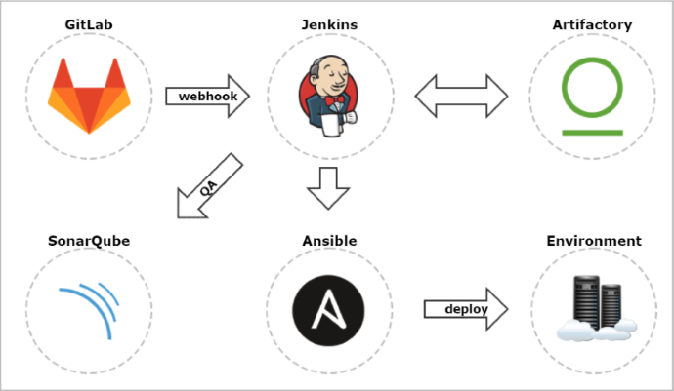

**Explaination:**

**Gitlab: GitLab is a web-based Git repository manager. Basically we will store all our codes in this. The purpose of this is that we can keep track of the codes, we can create a separate branch for each team i.e dev, tester or prod. We can check each activity about who has made changes, when he has made changes, where he has made changes. In addition to standard capabilities such as permissions management, viewing the source code, or viewing change history, it has many interesting features for code review and Continuous Delivery. We can setup the gitlab in such a way that for each code push it will build the project from scratch i.e compilation, code-review, testing , deployment.**

**Simialr Tools: Github, Bitbucket etc**

**Jenkins: Jenkins is a popular open-source automation server, with many plugins and a large community. With Jenkins we can perform various sorts of automated taks, like compiling, testing with selenium, code-review, and deploying in web servers. Jenkins comes with a huge bundle of plugins that can do wonders in our Devops culture.**

**Similar tools: Travis, CircleCI etc.**

**Artifactory: Artifactory is an open-source Maven repository manager. This will help us in storing the artifacts after each build in Jenkins. This is in turn helps us in version controlling so that we can roll back to any previous release in case of any failures in recent build. In comparison with its competitors, such as Nexus, it has a more user-friendly web interface.**

**Ansible: Ansible is an open-source automation engine that automates cloud provisioning, configuration management, and application deployment.  Ansible is a configuration management tool that is similar to Puppet and Chef. Nodes are managed by a controlling machine over SSH, and it uses an agentless architecture. Using this we can configure any server and if required we can deploy our build to the server.**

**SonarQube: SonarQube is an open-source platform for continuous code quality. It has a promotion pipeline feature that, using webhooks, can be easily integrated as a promotion step in the Continuous Delivery pipeline.**

**Similar Tools: Codacy, Clover etc.**

**Docker: Though this is not listed in the picture but this serves a very important role.  Docker makes it easy to create, deploy and use applications by packaging the application and all its dependencies (Code, runtime, system tools, system libraries etc.) into a virtual ‘container’. This means that developers can rest assured that the application will run properly on any other machine, regardless of any custom or conflicting system settings on the end user’s machine. This helps you to actually test your application in docker containers before actually deploying it to the production servers.**

**Nagios: Nagios is very popular open source monitoring tools we can monitor the services of any server, you will be able to monitor hosts resources by  web interface. Nagios is useful for** **keeping an inventory of your servers**, **and making sure your** **critical services are up and running. For using a monitoring system, like Nagios, is an essential tool for any “production server environment”.**

**Similar Tools: Zabbix, SolarWinds, etc**